ENGLISH III AP DOCUMENTARY PROJECT
GUIDEBOOK

“How did you do it? How did you capture what it was really like? How we felt, and how we made each other laugh, and how we got through the day; how did you do it?... Also how do cameras work?”
– Elllie Kemper as Erin on the final episode of The Office

Throughout the first semester this year you and a group of others will plan, direct, film, and edit your own documentary film. This project will count for a major grade in the second semester.

Besides being a major grade however, your film will also be competing in a contest across all the AP English classes. The top 3 films, as decided by your English III teachers, will be sent for judging in the UIL Filmmaking Contest. That means that producing a great film will not only net you a major grade 100, but also a chance to put “UIL Film Contest Semifinalist” or even “Finalist” on your college resumes. This project will not be easy, however following this guide will help ease the stress, simplify the process, and help you make an amazing documentary.

Much of what I’ve included in this guide are things I’ve learned from my own experience in the contest in 2015 as well as through years of self taught film work. This guide well help guide you in every step of the documentary filmmaking process, from coming up with an idea to making the finishing touches on your film. So whether you’re just in it for the grade, or you hope to create an award winning video, I hope this guide will be indispensible as you work through this project during the next few months.

- Nikolas Trusko

UIL FILM CONTEST RULES

Time Limit and Deadlines
- Each school is allowed to submit 3 films in each category: narrative, documentary, and animation
- Documentaries must be at least 3 minutes and no longer than 7 minutes in length
- All films must be submitted by January 15th

Eligible Material, Copyright, and Privacy
- Submitted films must be original works and are required to have clearances for music or other copyrighted material in the film.
- Adults are limited to involvement in interviews or voiceovers only.
- Students must meet eligibility requirements to compete.
- When using copyrighted music, you are allowed to use as many songs as you swant, but you are not allowed to use more than 30 seconds of any one song. This rule does not apply to royalty free music, uncopyrighted music, or music that you have legal permission to use.
- Documentaries have no limits on stock footage amounts.
- Everyone interviewed, recorded, or otherwise used on film must sign a photographic consent and release form (found on the UIL website).*

*THIS RULE CAN BE BENT DEPENDING ON THE SITUATION (You are filming a large crowd, the person has already signed a release form with their organization or school, etc.)

Judging
- Documentaries are judged in the following categories
- Originality
- Storytelling (does not apply as much to argumentative documentaries)
- Technical – During Production (Cinematography)
- Technical – Post Production (Voiceovers and Editing)
- Documentaries are rated in each category and given one of the following grades
- Fair (lowest score)
- Good
- Excellent
- Superior (highest score)
- Films go through 3 elimination rounds of judging before round 4, the finals contest in Ausin, Texas.
- Your judges will be film majors, teachers, and professionals throughout Texas
- *UNWRITTEN RULE* Judges tend to care more about the emotion and storytelling of films than anything else. If your film can give them goosebumps, make them laugh, cry, or anything in between, you have a good chance of advancing regardless of your video quality or ability to edit. Having a high quality video certainly helps though.

MATERIALS

In order to make a great documentary, you’ll need a few things.
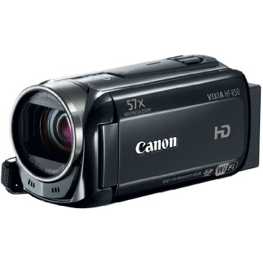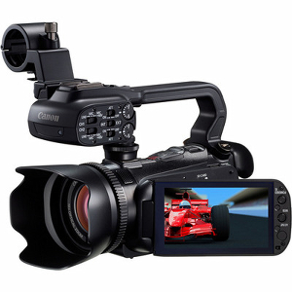
Canon HF50 Canon XA10

Camera: The price and quality of the camera you use will ultimately depend on your budget and how committed you are to the project. If you are only in the project for the grade, you should be fine with a lower level camcorder or camera, such as a Canon HF R50. Your parents or friends probably own a camera similar to this that you can borrow to use in your documentary. If not, you can find these cameras cheap used online or on sale at Best Buy or other electronics stores. A camera like this can also be rented online at atsrentals.com for about $88 a week.

If you are looking to seriously compete however, you’ll need a camera of higher quality. I shot my documentary with a Canon G20, which cost about $800. By all means, unless you’re planning on using a camera for years as I do, do not spend this much money. Go to atsrentals.com and rent a camera such as the Canon XA10 (a camera worth about $1500). A one-week rental will cost you about $105. That means that in a group of 5 each person would pay about $21. The length of your rental will ultimately depend on how much you’re going to film and when you’re going to film. You may only need to rent a camera for one day, or you may need to invest in a month long rental.

NOTE: The cheaper your camera is, the worse it will do in low light. If you’re planning on filming a lot at night, you should consider investing in a more expensive rental.

NOTE: No matter what you do, do not film with a cell phone camera. Cell phone camera footage is formatted to be played on a cell phone size screen. That means that when you try to import it into your computer, it will likely come out very pixilated or blocky.

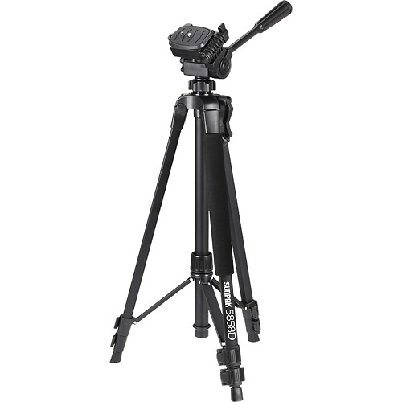
Sunpak 5858D Tripod

Tripod: Tripods are used to hold a camera steady when conducting interviews or filming other types of shots. Tripods are absolutely necessary if you don’t want a shaky looking video. You can find tripods for cheap (around $20) at stores like Best Buy. You can also create makeshift tripods by stacking books or other objects up high and putting the camera on top.

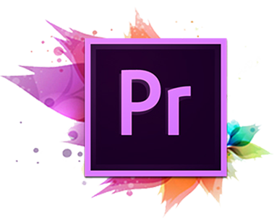
Final Cut Pro X Sony Vegas Adobe Premiere Pro

Editing Software: After all the filming is done, you’ll need software to edit what you’ve captured. If you’re only in the project for a grade, you should only need to use a free software like iMovie or Windows Movie Maker, which are included on most computers. Don’t expect to win any awards using free software however, iMovie and WMM are extremely limited in what they can do and trying to make an advanced film on them is completely impossible.

If you are more serious about the project, check out Final Cut Pro, Sony Vegas, or Adobe Premiere. These programs are all rather expensive (several hundred dollars each) so if you have a friend who happens to have one of the programs on the computer, buy them dinner and ask if you can come over for a few days to do your editing. There are other, less legal means, of getting this software as well.

NOTE: To prevent lag and crashing, download your editing software to the fastest computer you own, and try not to run other programs while your software is running.

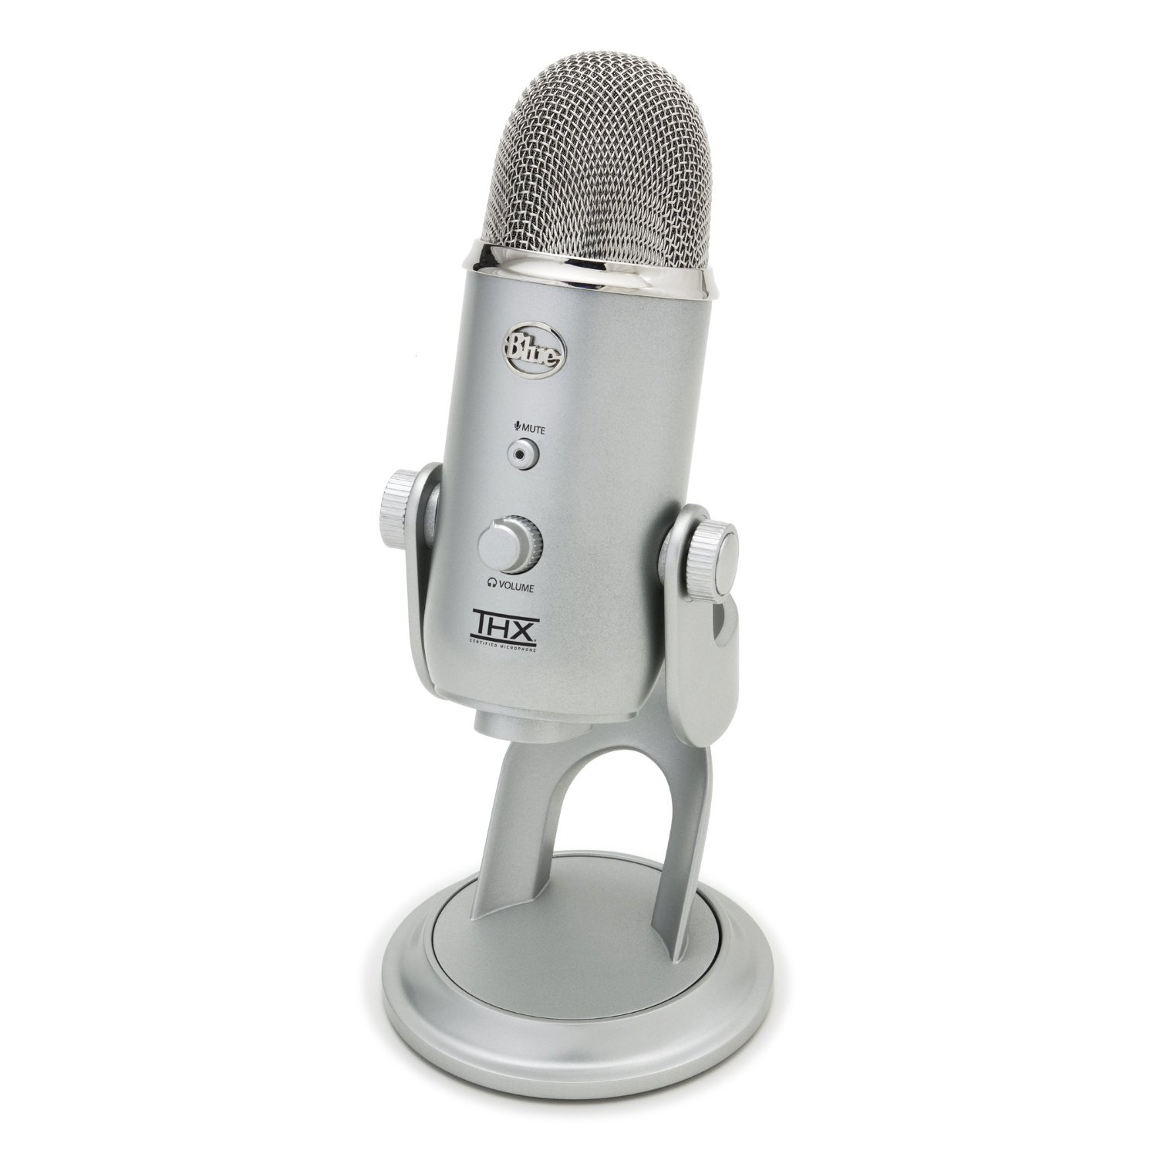
Blue Yeti Microphone

Microphone (for Voiceovers): Most computers come with a built in microphone that will record audio just fine. If you want, you can invest in a cheap USB mic such as the Blue Yeti.

When recording your audio for a voiceover, I recommend simply recording it on Audacity, a free software. Google the parameters your microphone requires and adjust settings accordingly (you can probably find YouTube tutorials for this).

Planning

When considering what to do your documentary on, there are two main types of documentaries to consider. These two documentaries will be graded on a different rubric.

Argumentative: In an argumentative documentary, you pick an issue that you feel strongly about and argue for or against a certain standpoint. Much like an argumentative essay, you’ll be picking a standpoint and backing up your argument with evidence. This evidence will come in the form of statistics, interviews, and sometimes footage.

Of the two types, argumentative documentaries require less time to film but more time to plan. You’ll have to decide who to talk to, what to say, and how to get your point across. Very little of your filming will be spontaneous and you’ll likely have less to work with than in an expository documentary. However, this also means you’ll be more in control of the process and can likely plan better than you could otherwise.

Very few professional documentaries are solely argumentative. Many are expository with an argument layered on top. You may do this as well.

EXAMPLES: Blackfish, Super Size Me, An Inconvenient Truth, Bowling for Columbine

Expository: In an expository documentary, you will pick a person, group, or event that you feel strongly about and tell “their story” through film. You will use interviews and a huge amount of footage to tell the story in a cinematic and exciting fashion that makes viewers interested from start to finish.

Of the two types, expository documentaries require more time to film but less time to plan. Often a lot of your “planning” will come after you’ve filmed and interviewed everyone and you’re ready to begin editing. Very much of your filming will be spontaneous, and you’ll often have to be constantly alert while you’re filming in order to capture the best possible shots. You’ll also need to know who to interview and when to interview them. For example, if you interview a football player before a game, their words will be very different than if you interview that same player after a game.

If you decide to do an expository documentary, YOU NEED TO PICK A TOPIC ASAP! Many topics will end up having fast approaching deadlines for when you can film them. For example, if you wanted to do an expository documentary on the hard work that students put in preparing for the Homecoming Dance, you would have to rent a camera start filming immediately. This goes for any other first semester activities the school is involved in. So get a group together, pick a topic, rent a camera, get permissions, and start filming as soon as you can.

If your budget is limited, expository documentaries leave a lot of room open for creativity. For example, if you were to do a documentary on Run Thru Crew, you could film the run thru process of just one week from start to finish and use the interviews you get to capture the story of Run Thru at Clements as a whole. That way, you would only need to rent a camera for one week rather than for two whole months while still getting the whole story.

NOTE: MOST OF THE UIL AWARD WINNING DOCUMENTARIES LAST YEAR WERE EXPOSITORY

EXAMPLES: Man on Wire, March of the Penguins, Taxi to the Dark Side, Hoop Dreams

Filming

After you’ve got your equipment together, its time to start filming. Ultimately, the way you film is up to you, however there is some practical advice to follow.

Audio: When trying to capture key moments in your documentary, audio plays a big piece. This won’t matter if you’re just going to mute the clip and play interview audio or music over the scene. However, if you intend on using the clip with its audio in tact, you should always be aware of the sound that is going on around you that could ruin an otherwise amazing clip. Things like buzzing air conditioners, passing cars, or loud children can be jarring and make it very hard to hear what’s going on.

When recording an interview, its absolutely important that you get to a quiet place. Here at Clements, good places to do interviews include empty classrooms, the hallways after school, offices, or the music practice rooms downstairs. When you’re doing an interview on the fly when you’re out filming however, finding a quiet place will be much harder. If a quiet place can’t be found, just try to get the interviewee to speak as loud as they can. Surprisingly, this situation can sometimes have its advantages, as things such as a loud crowd cheering in the background can convey feelings of excitement and emotion.

Interviews: Interviews will be the backbone of your documentary. You’ll need to capture interviews in order to tell the story or have evidence for your argument. When choosing who to interview, try to use a wide range of people in every position you can think of. For example, if you were doing a documentary on the football team, don’t just interview team members. Talk to coaches, parents, managers, trainers, fans, anyone that you can think of that might be able to add to your story. Remember that different people will have different perspectives on a situation, group, or event. For example, a senior’s dialogue might be more emotional while a freshman’s might be more exciting and anxious.

Interviews can be preplanned or, in the case of expository documentaries, on the fly. In a preplanned interview, you’ll be able to set up a tripod and ask a series of premade questions to your interviewee in a quiet place with a set up background. What questions you’ll ask will depend on your topic, but be sure to make these questions open ended so that your interviewee will have plenty to talk about. Unless your documentary is actually about the person you’re interviewing, you won’t be using the entire interview. In a 10 minute interview you’ll probably only use about 30 seconds to a minute at most.

On the fly interviews are much different. You’ll more play the role of a TV reporter, running up to someone at a pivotal moment or before or after the action to ask them a few quick questions. Sometimes you might catch two people at once and you’ll be able to interview with both on camera. Sometimes you might not even be “interviewing” them at all, but rather capturing their speech or shout to their group or team. In this type of interview however, timing is key. Once the moment is gone, its gone. Be sure to capture the thoughts and feelings of the moment while the moment is still there.

NOTE: When shooting an interview, no matter the situation, adhere to the “Rule of Thirds.” The Rule of Thirds essentially states that your main subject or subjects in a shot should always be somewhere in the left or right third of the screen, but never directly in the middle.

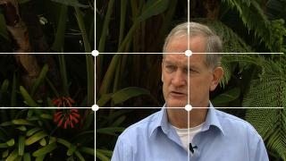
Demonstration of the Rule of Thirds in an interview

Footage: In order to make a great documentary, you’ll need a lot of footage, way more than you think you need. As an example, my documentary had more than 8 hours of footage captured for a 7 minute video. You won’t use everything you film, but when it comes to shooting a documentary, the more footage you can get the better. You never know what you might end up using when you edit, so film everything you can. By doing that, you can keep your options open when editing and you’ll never be stuck using a bad shot or repeating the same shot twice because you didn’t record enough.

On the shots themselves, try to film everything as cinematically as possible. To get the picture, watch professional documentaries or the UIL Film finalists from last year. Filming cinematic shots is hard to explain, so its best if you just look at examples and try to replicate those shots as best you can in your own filming. Generally speaking, close up shots are better at conveying intense emotion, while wider shots are better at conveying excitement. Putting a camera on the floor can yield surprisingly good results. Slowly zooming in or out works to create a nice effect too, depending on the situation.

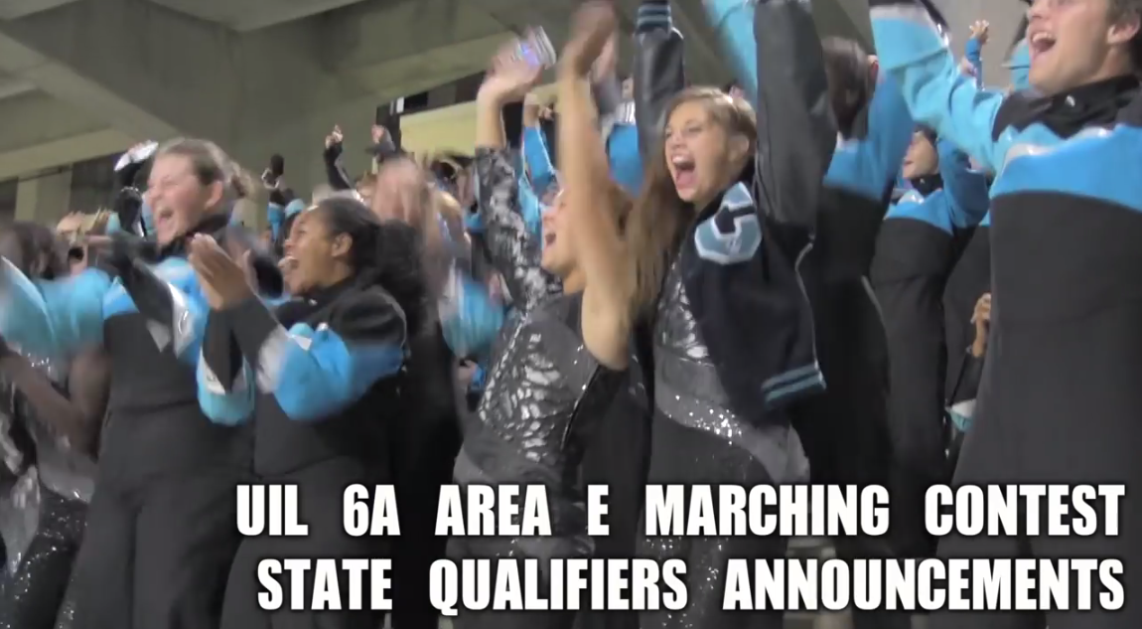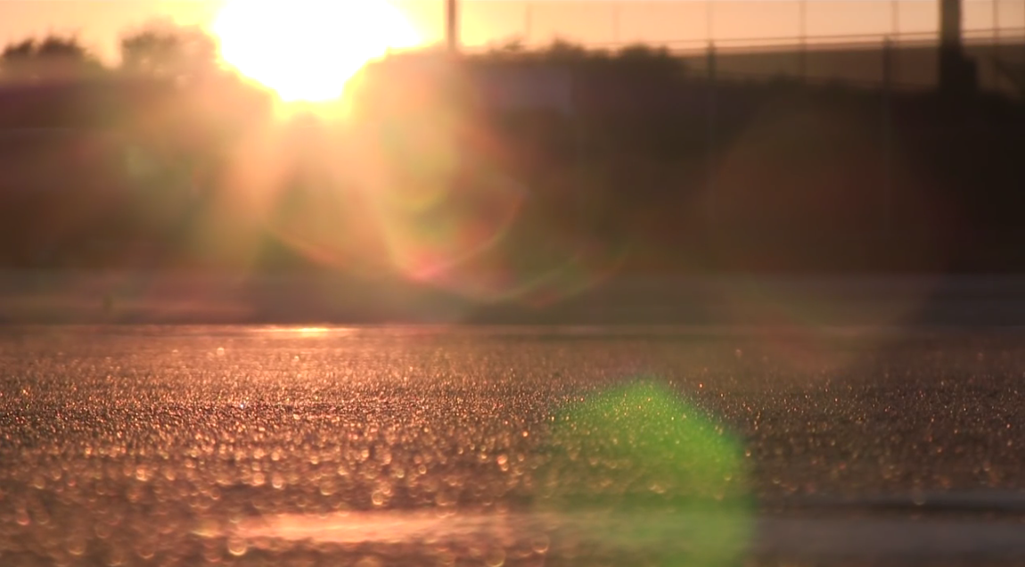
Wide angle shot conveys excitement Close up shot conveys emotion

As stated in the planning section, if you’re filming an argumentative documentary, you can capture footage at your leisure for the most part. For example, if you’re filming a documentary arguing against standardized testing, you can film various shots of students studying as well as close up shots of prep books or school supplies.

Expository documentaries rely much more heavily on timing and location. As previously stated, if your filming budget is limited you can often find a way to condense your filming time to just one week or a few days while still telling the whole story. If you do decide to do this, waste no time in capturing every shot from every angle you can. You might even consider renting two cameras just to make sure you get everything imaginable. Additionally, try your absolute best to capture the most emotional moments of your topic (Seniors winning the last game of their high school career, students finding out that they are not advancing to state, etc.) Its those moments that can make or break your documentary in the end.

Editing

After you’ve finished recording all of your footage, interviews, and audio, you’re ready to begin editing. Editing is a very long process, and there’s no way you’ll be able to edit everything in one day, especially if you’re planning on competing. It helps to make an editing plan for yourself in order to better gauge your time according to your schedule. You could plan on spreading the work over a few Saturdays, or you could take out a few hours each day of your Thanksgiving Break. When you decide to edit is up to you, as long as you give yourself enough time to finish the video.

Having all your group members present when editing is not only unnecessary, its distracting. You should decide early on who in your group will take care of the editing, and leave that person to it. Make sure this person is responsible, dedicated, and creative. Remember, whoever you entrust the editing job to will ultimately decide how your video will come out.

How exactly to edit depends not only on the software you are using, but also on your editor’s creativity, the mood of the film, what you’re trying to cover, etc. There are however, some easy rules to follow to ensure a great film. As always, watching examples is the best way to get an idea of what looks good and what’ll help your documentary stand out among the rest.

NOTE: THIS ADVICE ASSUMES YOU’RE USING FINAL CUT PRO. VEGAS AND PREMIERE CAN ALSO DO EVERYTHING HERE, BUT IT WILL LIKELY HAVE A DIFFERENT WAY OF DOING IT THAT YOU’LL HAVE TO LOOK UP.

Text:

ALL TEXT: No matter what kind of text you’re using, turn on text outline, set outline color to black (or any color you want), and set it to a high blur setting. This will prevent your text from blending into the background or having undefined borders. It will also make the text stand out more. Additionally, avoid bright colors as they’re a strain on the eyes.

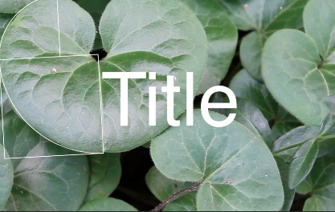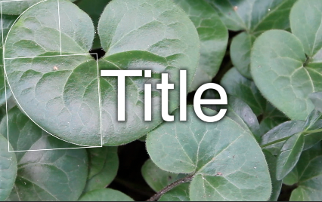
Text without blur outline Text with blur outline

OPENING TEXT: If you’re including them, keep your opening credits subtle and neat. Don’t put in an obnoxious opening text block using stock text effects with loud music. It wastes time and probably won’t match the rest of your documentary. Try to have your opening credits flow well with the footage, fading in and out or appearing at appropriate times and using the correct effects. If you can, try to get your text movement to match the background music. For examples on how to do this, watch last year’s state finalist documentaries.

TITLE: Your title is open game, as long as you present it well and make it look nice. Make sure you pick a font and color that matches your documentary’s theme. You can even include logos in your title if its appropriate.

INTERVIEW DESCRIPTIONS: When showing an interview, place text in one of the corners of the screen (depending on where your interviewee was sitting when you filmed the interview) and type the interviewee’s name and description. For every interview you film, you should have this text in the same font, color, and size, as well as same location if possible. You can include a logo here too, if applicable. Its also always a good idea to include a text transition in the beginning of the clip, as the transition will draw viewer attention to the text itself.

Interview Description

STATISTICS AND DATA: If your documentary includes statistics and data, try to present them in a visually appealing manner, including text movements and transitions. A plain white or black background is boring, and should be avoided at all costs. Instead, try to include a slow moving background and appropriate animated text. I would recommend taking some of your footage, slowing it down, and applying a Gaussian blur over it. That way, the background will be moving but not distracting and your text will appear just fine in front of it.

DATE, TIME AND LOCATION: If you’re using text to show a scene’s date, time, and location, make sure the text matches the mood of the scene. If you’re presenting a sunrise on the day of a big game, you could have the text fade in slowly or appear with a close up shot. If you’re showing the passage of time (“1 Week Later…”, etc.) you could have scene fade to black with the time passage presented and then fade again to the next scene.

CREDITS: Unless you have enough time to make it fit in your 7 minute time limit, don’t include ending credits, especially if you already have opening credits.

Audio:

ALL AUDIO: Before you export your video, watch the entire thing and check audio levels. If you notice one part of your video is louder or quieter than another part, fix it.

Additionally, if you have an audio track that runs for awhile and then changes to a second track, you absolutely need to layer your two tracks together at the ends and have your first track fade out while your second track fades in. By doing this, you can avoid silences and obvious changes in background sound.

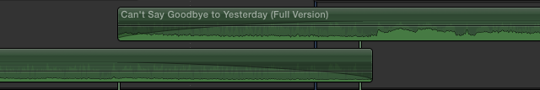
Audio tracks fading out and fading in

FOOTAGE AUDIO: Most of the time, your clips will be muted and you’ll have dialogue or music playing over it. If your clip includes audio you want to use, try to extend the clip out and have the audio fade in in the beginning and fade out at the end. That way, you won’t get a sudden jarring background noise that appears out of nowhere when you play back the video. You may not need to do this depending on the situation.

Additionally, if you want to have the footage appear while the interviewee is still talking, turn down the footage audio but do not mute it. Have the audio come back up once the interviewee’s dialogue is gone.

INTERVIEW AUDIO: When presenting audio from an interview, you don’t have to keep the interviewee on screen the whole time. Actually, it’s a much better idea to have the interview audio start before the interviewee appears on screen. You should also have the interviewee’s audio continue after they’re no longer on screen, if possible. If this is hard to visualize, watch last year’s UIL Finalists to get an idea of what this looks/sounds like.

Additionally, you may have an issue where your interviewee stutters or says a number of good lines in between mistakes. Problems such as these can simply be rectified by deleting the problem spots and bringing the good parts together on your editing timeline. Just make sure that you only do this when the interviewee is not on screen (I.E. just their voice is playing), so you can avoid choppy, obvious looking edits.

And finally, when your interviewee is speaking, have your background audio fade to a lower volume so that they can be heard more easily. Remember to bring your background sound back up once the interviewee’s voice clip is finished.

SOUND EFFECTS: Sound effects, if used appropriately, can be a great help in transitions and clips where the audio is unusable. Most video editing softwares have their own sets of stock sound effects. However, if you can’t find the exact one you want you can often find what you need for free on the Internet.

In transitions, you can use smooth sound effects to supplement a slow transition, or jarring ones to supplement a quick cut to black or clip change. Ensure you have the timing correct however, as a sound effect that is incorrectly timed won’t make any sense to the viewer

In clips, sound effects can be used to fix audio problems or mask bad audio. For example, lets say you’re editing some background footage in the forest. The only problem is that the forest is right next to the freeway, where the sound of fast moving cars intrudes on the peacefulness of your shot. Rather than use the original audio, you can mute the clip and put in a “forest sounds” audio track you found online instead. You can use a similar technique on a smaller scale too. Lets say you got an amazing shot of a football player kicking a field goal, but the sounds of the crowd make it impossible to hear the ball actually being kicked. You can insert a sound effect at the correct moment that sounds like a ball being kicked in order to make up for this fact.

MUSIC: DO NOT UNDERSTATE THE VALUE OF MUSIC IN YOUR VIDEO! No matter what kind of documentary you’re making, you absolutely need to have music playing at all times. Even when other audio is playing, have music playing low in the background too.

At its most basic use, background music can cover up moments of silence and make dialogue or clips seem more alive. Clips without some kind of music in the background will come off as boring and unprofessional, and make your audience lose interest. For that reason, you need to pick a few music tracks to have running in the background while your interviewees are speaking and your footage is playing. Make sure that your music matches the mood of the scenes or interviews you are presenting, and that when you change or loop music that you have the music layered at the end so that the change isn’t obvious.

Besides being used in the background, music can be used to create an intense emotional impact on your audience. There’s no one set way to do this, and how you do this will really depend on your topic. My documentary relied very heavily on this, to the point where I can say that I would never have been able to win if I hadn’t used music the way I did. If you can find music that’ll make your audience smile, tear up, or feel shivers, INCLUDE IT!

NOTE: UIL rules state that you can only include 30 seconds of any one copyrighted song. If you have a song in mind that has lyrics that create emotional impact in a scene, use that song. Just make sure you use the best 30 seconds of it that you can. Stock or uncopyrighted music on the other hand has no such limit, so use it to your heart’s content. Incompetech.com has an excellent selection of uncopyrighted music, including both emotional sounding pieces and background pieces that work great in documentaries.

Footage:

ALL FOOTAGE: In order to fit your clips into the 7 minute time limit, you may need to speed them up or slow them down. In general, speeding up a clip between 100% and 110% will not make a very noticeable difference when you play it back, however you will notice that the clip is now a few valuable seconds shorter than it was before! The same applies to slowing it down (90% - 100%) if you need a clip to last longer. You can try to extend the speed more, depending on the clip. As long as the difference isn’t noticeable, do what you need to do.

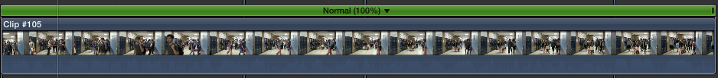
Normally this clip is 10 seconds long

At 110% speed however, its 8 seconds long

MUTED FOOTAGE: Most of the footage you’ve recorded won’t end up being used, and much of what you do end up using will be muted. That’s because footage isn’t meant to tell the story on its own, its supposed to provide visuals for the interviewee’s dialogue. In order to do this, you’ll need to cut up your footage a lot and slip bits and pieces in wherever they fit. This means that your footage will not need to be consecutive by any means. If you record over the course of a week, you can have one clip you recorded on Monday, followed by one recorded on Thursday, then Tuesday, Saturday, etc. As long as your footage looks good, continuity won’t matter, since nobody will really know what order things happened in except you.

UNMUTED FOOTAGE: *SEE AUDIO SECTION*

IMAGES: You may need to use still images in your documentary. If you or your interviewee has a physical version of the image (not one printed off a computer), film the image itself, instead of scanning it onto a computer. By doing this, your picture will look much more dynamic and less out of place amongst your footage.

If you can’t do this and you have to use an image you either scanned or pulled off the internet, find the best quality version of the picture you can, do not ever use blurry images. Once you have your picture imported, make sure you stretch it or shrink it to fit the dimensions of the screen. Finally, to make sure the picture isn’t stagnant and boring, have the picture slowly zoom while its on the screen. Different editors have different ways of doing this, so look up the best way to create the zoom effect.

TRANSITIONS: In a documentary, transitions should be used sparingly. Only use transitions when the mood of your clips calls for them and absolutely do not use them on every clip.

As for what transitions to use, fade ins and outs work great for every documentary, plus you can easily shorten or extend their length to your liking. Moving or animated transitions probably shouldn’t be used, unless your documentary is being editing in a very flashy manner.

OTHER: YOU CAN FIND THE ANSWERS TO PRETTY MUCH ALL OF YOUR EDITING QUESTIONS BY GOOGLING THEM OR WATCHING TUTORIALS ONLINE

